**LAB 3**

# Exercise 1:

## CODE:

<!DOCTYPE html>  
<html>  
<head>  
 <style>  
 #compact {  
 background-color: pink;  
 }  
 #midsize {  
 background-color: blue;  
 }  
 #sports {  
 background-color: red;  
 }  
 </style>  
</head>  
<body>  
<ol type="I">  
 <li id="compact">Compact  
 <ol type="A">  
 <li>Two Door  
 <ol type="1">  
 <li>Honda Civic</li>  
 <li>Ford Fiesta</li>  
 <li>Mini Cooper</li>  
 </ol>  
 </li>  
 <li>Four Door  
 <ol type="1">  
 <li>Toyota Corolla</li>  
 <li>Hyundai Elantra</li>  
 <li>Chevrolet Cruze</li>  
 </ol>  
 </li>  
 </ol>  
 </li>  
 <li id="midsize">Midsize  
 <ol type="A">  
 <li>Two Door  
 <ol type="1">  
 <li>Honda Accord</li>  
 <li>Toyota Camry</li>  
 <li>Hyundai Sonata</li>  
 </ol>  
 </li>  
 <li>Four Door  
 <ol type="1">  
 <li>Nissan Altima</li>  
 <li>Ford Fusion</li>  
 <li>Chevrolet Malibu</li>  
 </ol>  
 </li>  
 </ol>  
 </li>  
 <li id="sports">Sports  
 <ol type="A">  
 <li>Coupe  
 <ol type="1">  
 <li>Ford Mustang</li>  
 <li>Chevrolet Camaro</li>  
 <li>Dodge Challenger</li>  
 </ol>  
 </li>  
 <li>Convertible  
 <ol type="1">  
 <li>Mazda MX-5 Miata</li>  
 <li>BMW Z4</li>  
 <li>Porsche Boxster</li>  
 </ol>  
 </li>  
 </ol>  
 </li>  
</ol>  
</body>  
</html>

## OUTPUT:

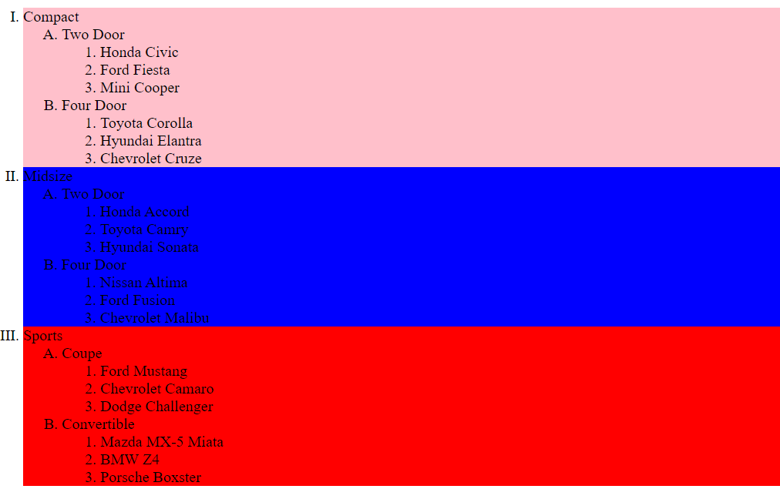

# Exercise 2:

## CODE:

<!DOCTYPE html>  
<html>  
<head>  
 <link rel="stylesheet" type="text/css" href="t2.css">  
</head>  
<body>  
<nav>  
 <ul>  
 <li><a href="index.html">Home</a></li>  
 <li><a href="product.html">Product</a></li>  
 <li><a href="contact.html">Contact</a></li>  
 <li><a href="about.html">About</a></li>  
 </ul>  
</nav>  
<h1>Welcome to Our Website!</h1>  
<p>This website is all about our amazing products and services.</p>  
</body>  
</html>

body {  
 font-family: Arial, sans-serif;  
}  
  
nav {  
 background-color: #333;  
 color: white;  
 padding: 15px;  
}  
  
nav ul {  
 padding: 0;  
}  
  
nav ul li {  
 display: inline;  
 margin-right: 10px;  
}  
  
nav ul li a {  
 color: white;  
 text-decoration: none;  
}  
  
h1 {  
 color: #333;  
}  
  
p {  
 color: #666;  
}

## OUTPUT:



# Exercise 3:

## CODE:

<!doctype html>  
<html class="no-js" lang="">  
  
<head>  
 <meta charset="utf-8">  
 <meta name="viewport" content="width=device-width, initial-scale=1">  
 <title>Login Form</title>  
 <link rel="stylesheet" href="style.css">  
 <link href='https://unpkg.com/boxicons@2.1.4/css/boxicons.min.css' rel='stylesheet'>  
</head>  
  
<body>  
<main>  
 <section class="wrap">  
 <form action="#">  
 <h1>Login</h1>  
 <div class="inputBox">  
 <input type="text" placeholder="Username" required>  
 <i class='bx bxs-user'></i>  
 </div>  
  
 <div class="inputBox">  
 <input type="password" placeholder="Password" required>  
 <i class='bx bxs-lock' ></i>  
 </div>  
  
 <div class="rememberMe-forgotPassword">  
 <label><input type="checkbox"> Remember me</label>  
 <a href="#">Forgot password?</a>  
 </div>  
 <button type="submit" class="btn">Login</button>  
  
 <div class="registrationLink">  
 <p>Don't have an account? <a href="#">Register</a></p>  
 </div>  
  
 </form>  
 </section>  
</main>  
  
</body>  
  
</html>

*{  
 margin: 0;  
 padding: 0;  
 box-sizing: border-box;  
 font-family: sans-serif;  
}  
  
body{  
 display: flex;  
 justify-content: center;  
 align-items: center;  
 min-height: 100vh;  
 background: url("img.jpg") no-repeat;  
 background-size: cover;  
}  
  
.wrap{  
 width: 420px;  
 background: transparent;  
 border: 2px solid rgba(255, 255, 255, .2);  
 backdrop-filter: blur(20px);  
 box-shadow: 0 0 10px rgba(0,0,0,.2);  
  
 color: #ffffff;  
 border-radius: 10px;  
 padding: 30px 40px;  
}  
.wrap h1{  
 font-size: 36px;  
 text-align: center;  
}  
.wrap .inputBox{  
 position: relative;  
 width: 100%;  
 height: 50px;  
 margin: 30px 0;  
}  
.inputBox input{  
 width: 100%;  
 height: 100%;  
 background: transparent;  
 outline: none;  
 border: 2px solid rgba(255,255,255,.2);  
 font-size: 16px;  
 color: #ffffff;  
 padding: 20px 45px 20px 20px;  
}  
.inputBox input::placeholder {  
 color: #ffffff;  
}  
.inputBox i{  
 position: absolute;  
 right: 20px;  
 top: 50%;  
 transform: translateY(-50%);  
 font-size: 20px;  
}  
  
a{  
 color: #ffffff;  
 text-decoration: none;  
}  
a:hover{  
 text-decoration: underline;  
}  
.wrap .btn{  
 width: 100%;  
 height: 45px;  
 background: #ffffff;  
 border: none;  
 outline: none;  
 border-radius: 40px;  
 box-shadow: 0 0 10px rgba(255, 255, 255, .2);  
 cursor: pointer;  
 font-size: 16px;  
 color: #333;  
 font-weight: bold;  
}  
  
.wrap .registrationLink{  
 font-size: 14px;  
 text-align: center;  
 margin: 20px 0 15px;  
}  
.rememberMe-forgotPassword{  
 margin-bottom: 25px;  
}

## OUTPUT:

